2024

11th Annual Leadership Awards Program

Celebrating Leaders in Corporate Canada

NOMINATION PACKAGE

Mentor of the Year Award, Sponsored by Electronic Arts
Student of the Year, Sponsored by Sun Life
Social Impact Award, Sponsored by RBC
Inclusion Champion of the Year, Sponsored by CIBC
Woman of Distinction Award, Sponsored by Manulife

Ascend Innovator of the Year

The Ascend Canada Leadership Awards are presented annually to individuals who exemplify personal dedication, professional achievement and commitment to the community.

NOMINATION ELIGIBILITY
To be eligible for nomination, each nominee must be:
- An individual who is employed in Canada and who is NOT a member of the Ascend Canada Board of Directors or Awards Committee or Volunteers of Ascend Canada.
- Available to attend and receive the award at the Ascend Canada Gala in May 2024 (date TBD).

AWARDS PROCESS
Nomination Process
Nominators may recommend individuals who exhibit exceptional leadership abilities, have a proven professional track record and live Ascend Canada’s values. Nominations can be made by completing all sections of the nomination form and submitting the package and accompanying materials to awards@ascendleadership.ca by November 30th, 2023. An overview of the items required from the nominators is provided below:
- Completed Nomination Form
- Additional supporting documents (i.e. letters of recommendation, testimonials, articles, journals/publications, media coverage, etc.) provided within a maximum of two pages.
- Signed consent form
Selection Process
After nominations are received, they will be reviewed by a Selection Committee comprising representatives from Ascend Canada’s Board of Directors, Officers and general members. Candidates will be short-listed and contacted for further information.
Once the selection process is completed, Ascend Canada will advise award recipients and nominators of the committee’s decision. Award recipients will be required to attend the Ascend Canada Gala on May 2024 (date TBD) to receive their award.

Key Dates
- November 30th, 2023 – Nominations for 2024 awards program closes
- January 2024 – Short-listed nominees may be contacted for further information
- February 2024 – Recipients are notified
- May 2024 –Awards will be presented at the Ascend Canada Gala. The date will be finalized in due course.
NOMINATION CATEGORIES

Mentor of the Year Award, Sponsored by Electronic Arts
This award recognizes the dedication, guidance and leadership of an individual who has made a significant contribution to several Pan-Asian individuals’ quality of life and professional development through:

Leadership: Providing ongoing career guidance to develop leadership capabilities in others.

Sponsorship: Promoting and advocating for mentees.

Community Involvement: Demonstrating commitment to diversity and inclusion related mentorship initiatives.

Student of the Year, Sponsored by Sun Life
A Pan‐Asian individual who is enrolled in school and is under 25 years of age who has demonstrated early leadership qualities through personal performance, volunteerism and making a difference in the community through their impact, leadership and commitment to learning and development.

Impact: Has made a positive impact at school (i.e., high school, post-secondary) and in the community to advocate for change at a professional or social level.

Leadership: Demonstrating inclusion through leadership; an individual who 'walks the talk' and is seen as a leader amongst their peers.

Development: Is proactive and committed to engaging in continuous learning opportunities that are focused on developing skills and capabilities.

Social Impact Award, Sponsored by RBC
A Pan-Asian individual who creates value through sustainable solutions in the community and being a differentiator on the most important societal challenges by making an impact, demonstrating strong leadership, and creativity.

Impact: An Individual who develops or improves the processes, methods, systems, products or services that have meaningful impact in one or more the following areas: social, economic, environment, cultural, health, political, scientific and technological.

Leadership: A change agent in the industry that has created and implemented a tangible strategy that has positively impacted others.

Creativity: An individual who creates a concept and/or approach that truly disrupts conventional thinking and methodologies when dealing with real world issues within the community.

Inclusion Champion of the Year, Sponsored by CIBC
Individual who has advanced inclusion in their organization and the community with measurable impact.
Impact: Through their passion and clear vision, this individual has been able to break new ground and play a key role by removing barriers and enhancing the community to enable a more inclusive society.

Leadership: This individual has demonstrated extraordinary commitment and leadership by creating effective solutions or ideas to meaningfully spark change in the workplace and/or community and foster inclusive behaviours.

Sponsorship: This individual advocates for an environment that is free of bias and discrimination.

Woman of Distinction Award, Sponsored by Manulife
Pan-Asian female who has dedicated her efforts to empower other Pan-Asian women and advance their careers.
Impact: An individual who has been a trailblazer and shown a measurable impact for gender equality through their significant contributions to the organization and community.

Leadership: This individual has demonstrated exemplary leadership by modeling inclusive behaviours, achieving excellence professionally and impacting and influencing other leaders to embrace inclusivity.

Sponsorship: This exceptional individual is an advocate of women and is passionate towards unlocking their potential. This individual is a role model who has inspired many women.

In addition, the Awards Selection Committee will look for the following broad measures to further differentiate nominations:
- Boldness – Did the individual challenge the status quo and chart a new course of action?
- Execution – How effective was the individual in executing against plans and leading through the execution/implementation process?
- Results – What are the results or accomplishments that the individual has built over his/her career?
- Impact – What type of impact did the individual have on an organization/community/program?
To contact us for more information or questions regarding the awards or the nomination process, please email awards@ascendleadership.ca

NOMINATION FORM
NOMINATION DEADLINE – November 30th, 2023

Nominee Information
Name: _____
Award Category: ______
Company/Organization Name: ____
Current Position: ____________
Business Phone: ______________________________________________________________________
Email: ____
Nominator Information
Name: __________
Company/Organization Name: _______________
Current Position: _______________________
Business Phone: _________________________
Email: _______________

- Statement of Support
Provide a short summary of your reasons for nominating this individual. [200 words or less]

- Results & Impact
Provide a summary of the nominee’s career and accomplishments, his/her impact on an organization/community/program, and your working relationship with the nominee. [200 words or less]

- Award-specific detail
Address the "story" behind the reasons of your nomination with respect to the chosen award category and provide details for each of the selection criteria (as provided on page 2 and 3). [500 words or less]
Should include:
- Specific examples of work undertaken and successfully executed
- Specific characteristics and strengths attributable to the nominee’s success

Additional Notes: one-page maximum
Provide backup information, including:
- Supporting testimonials, media, additional work/projects, external recognition for the nominee, journals/publications, etc.
- Other interesting information that would help promote the nominee
Maximum 2 links

NOMINATION PACKAGE CHECKLIST

Required by the Nominator

A completed Nomination Form including nominator and nominee information and response to questions submitted to awards@ascendleadership.ca by November 30th, 2023. The completed Nomination Form should explicitly address the specific key criteria applicable to the award category of interest.

Advise nominee that a nomination has been put forward in their name.

Required by Nominee (if contacted by Ascend Canada for further review)

A curriculum vitae (CV) or resume outlining the nominee’s background, career and any activities that qualifies him/her for nomination in one of the three categories.

A signed consent form, which will be provided to the nominee at a later date.

OUR AWARD SPONSORS

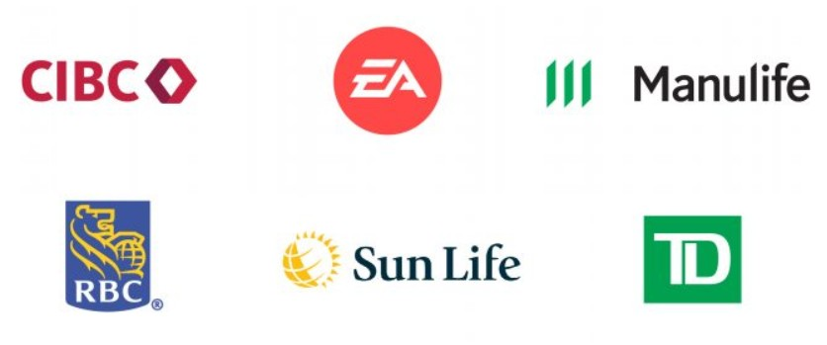

Connect with us at https://ascendleadership.ca/awards-program/
Contact us at awards@ascendleadership.ca
Follow us on LinkedIn: Ascend Canada

